Conditions in bash scripting

If-then script
Created a file if-script.bash and edited that file with following script
count=100
if [ $count -eq 100 ]
then
echo Count is 100
else
echo Count is not 100
fi
change the permissions to 755
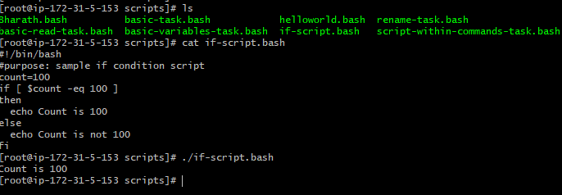
count=10
if [ $count -eq 100 ]
then
echo Count is 100
else
echo Count is not 100
fi


To Check a file
Created a file bunny in a directory scripts
Edited the file using bash script
#!/bin/bash
#purpose: writing the script to check the text file
echo
if [ -e /root/Bharath/scripts/bunny ]
then
echo "file exist"
else
echo "file dose not exist"

fi
echo



#!/bin/bash
#purpose: writing the script to check the text file
echo
if [ -e /root/Bharath/scripts/bunn ]
then
echo "file exist"
else
echo "file dose not exist"

fi
echo


Case statements;
#!/bin/bash
#purpose: excuting the case script
echo
echo Please chose one of the options below
echo
echo 'a = Display the current working directory'
echo 'b = List file and directories'
echo 'c = Display the date and time'
echo 'd = Check System uptime'
echo
read choices
case $choices in
a) pwd;;
b) ls;;
c) date;;
d) uptime;;
*) echo Invalid choice try again.
esac

